Neal Noble  
IT333  
Exercises - Heaps

1a. Show the result of inserting 10, 12, 1, 14, 6, 5, 8, 15, 3, 9, 7, 4, 11, 13 and 2, one at a time, into an initially empty binary heap

1,3,2,6,7,5,4,15,14,12,9,10,11,13,08 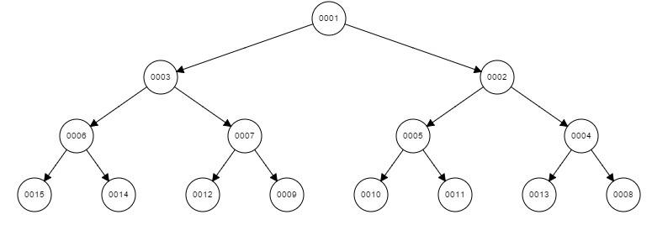

1b. Show the result of using the linear-time algorithm to build a binary heap using the same input.

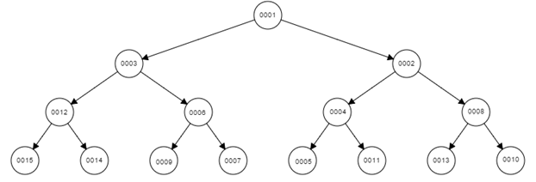

2. Show the result of performing three deleteMin() operations in the heap of the previous exercise.

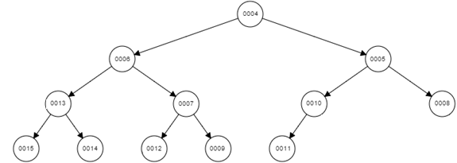

3. Suppose that we instead placed elements in a binary heap starting at index zero in an array. Given the index of an element in the tree, what would be the calculation to find the:

a) index of the parent node  
b) index of the left child node  
c) index of the right child node

4. How many nodes are in the large heap in Figure 6.13 of your book?

 2^0 + 2^1 + 2^2 + 2^3 + 2^4 + 2^5 + 2^6 + 2^7 + 97 = 225

5. A d-heap is a more general version of a binary heap where each node has up to d children. The heap property of the tree would be similar to a binary heap in that each of the d children of a node must be larger (for a min-heap) than the parent node. How would this design affect the runtime analysis for a heap structure?